Session 2.2:

Task: 3 create a file max-temp.txt in local FS. Put some 10-15 records of date and temperature example: dd-mm-yyyy,temperature Example: 10-01-1990,10 10-02-1991,20 Move this file to HDFS at /user/acadgild/hadoop.

There is no file ‘max-temp.txt’ in local fs:
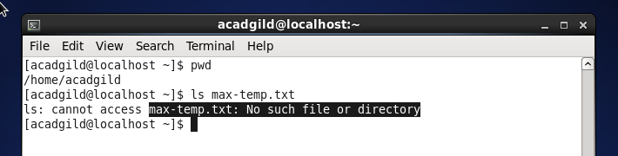

Creating a file max-temp.txt in local FS:
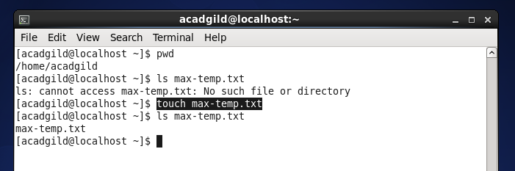

Adding 10-15 records of date and temperature, in ‘’max-temp.txt”:
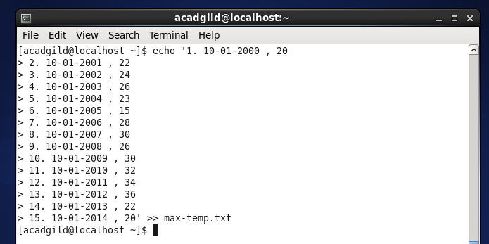

Records added in to ‘max-temp.txt’ file in local file system:
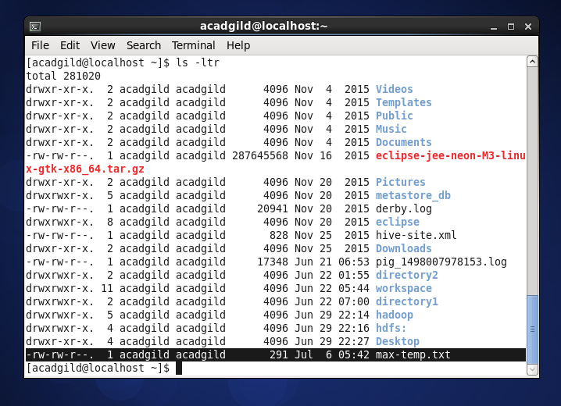

Records added in ‘max-temp.txt’ file located in local FS, below screen showing records in ‘max-temp.txt’ file:
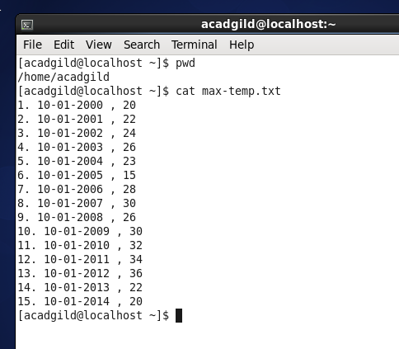

Moving ‘max-temp.txt’ file from local fs to HDFS at /user/acadgild/hadoop.
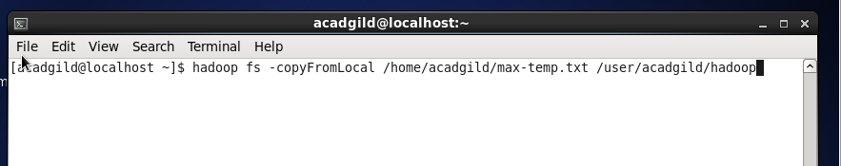

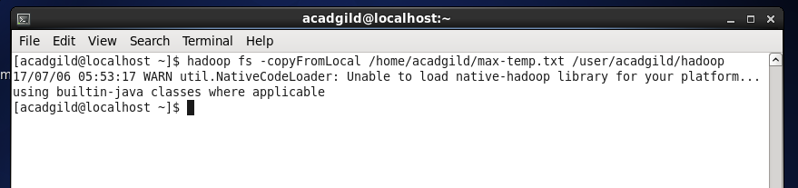

File copied successfully from local fs to /user/acadgild/hadoop
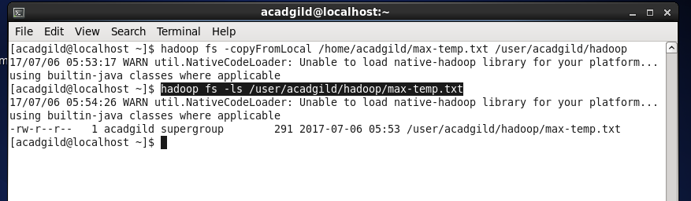

Tasks: 4 Change the permission of the file /user/acadgild/hadoop/max-temp.txt, such that only the owner and the group members have full control over the file. Others do not have any control over it.
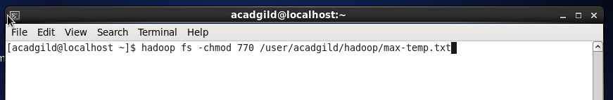

Changing the permission of the file /user/acadgild/hadoop/max-temp.txt, so that only owner and group members have full control over the file [full control = read, write and execute]. Others do not have any control over the file – so it is chmod 770:
